France Study Abroad, May 2018
Natalie Hanson
There was no better way to complete my time in ABE at Iowa State than by studying the sustainability of our global food supply through a comparison of France and the United States. Throughout the spring semester, we completed a course learning about French culture, sustainability concepts, and traveling abroad. The real fun came in the last two weeks of May when our group traveled to Paris for some hands-on (or should I say mouths-full) experiences in the French food culture. We baked macarons, made chocolates, tasted cheese, toured a winery, served the refugee community, and more. One highlight of the trip for me was shopping in the eclectic Montmarte district, snacking on strawberries, croissants, baguettes, and French cheeses as we hiked up and down the hilly streets of the historic neighborhood. I would highly recommend this trip to anyone who wants to learn more about the sustainability of food systems and loves eating delicious food!

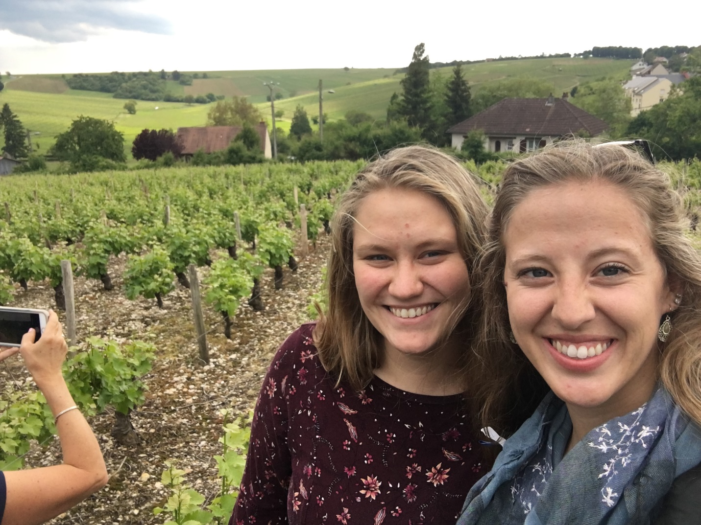
Courtney Perreault and me in a Sancerre vineyard

The view overlooking Sancerre, France
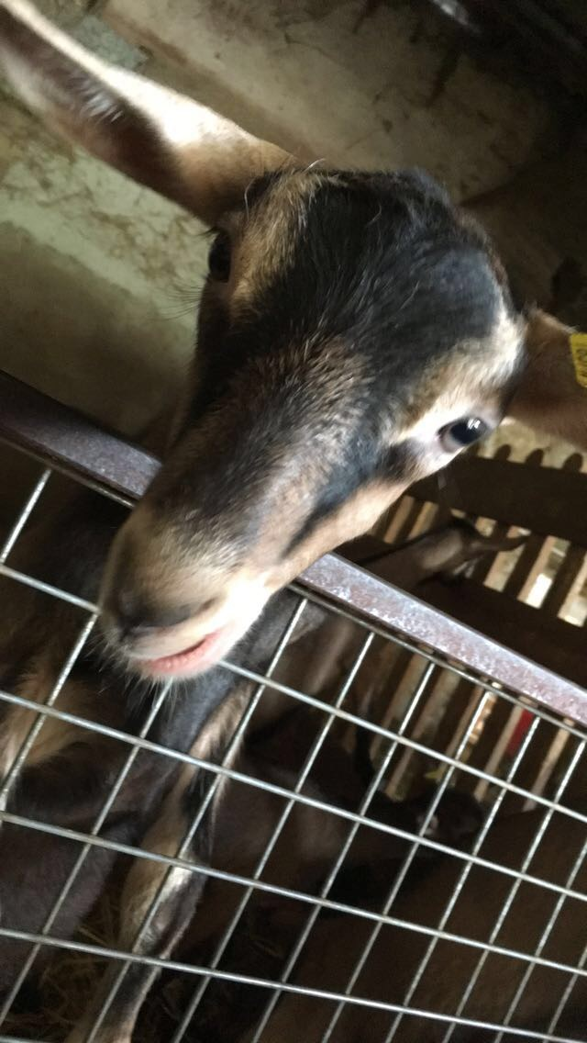
A friendly goat from the goat cheese farm we visited
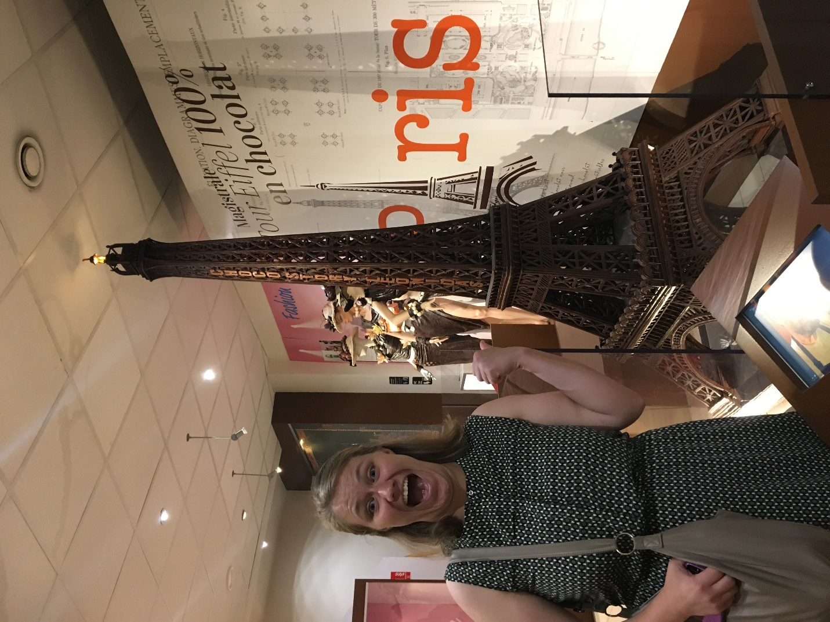
A chocolate Eiffel tower! I wish I could have eaten it all...

