September 14, 2015
Contact:
Charles Schwab
Agricultural and Biosystems Engineering Professor and Extension Specialist
515-294-4131
cvschwab@iastate.edu
Take Precautions Now for Safety During Fall Harvest
Remember to read instruction manuals for safety procedures
AMES, Iowa—Harvest is historically the most dangerous time of year for agriculture. During National Farm Safety and Health Week, Sept., 20-26, Iowa State University Extension and Outreach wants to remind everyone to regularly read instruction manuals about potential dangers of farm equipment and to be diligent in preventing farm injuries.

Reading and following the operation and instruction manuals are often overlooked as tedious or non-essential. However, packed in those printed pages is wisdom that can increase a person’s safety and well-being.

For example, air-compressor equipment manuals usually contain warning notices or procedural steps alerting operators that failure to remove condensation will cause the tank to rust prematurely.

“Draining the moisture from the tank may be viewed as an unnecessary task,” said Charles Schwab, professor and extension specialist in agricultural and biosystems engineering at Iowa State University. “Unfortunately, if these manual procedures are not followed, there is a serious potential for injury.” With the case of the air-compressor tank, the moisture in that tank will cause it to rust.

Schwab acknowledges that over time, internal rusting weakens the structural integrity of the tank which can potentially create a violent explosion.

“When under pressure pieces, or the tank itself, will become projectiles that can inflict injuries or cause damage,” said Schwab. “No one can predict when a rust-weakened tank will explode and where the projectiles will fly.”

The images from one such explosion, where the bottom of the compressed air tank exploded and launched the entire tank vertically into the roof of the building, demonstrate its violent nature. It removed part of the roof before falling back to the ground.

“Farmers and agriculture professionals need to realize that reading and following operation and instruction manuals can prevent injuries, like the example of the eventual rusting and explosion of the air-compressor tank,” Schwab said.
###
Related links:
Agricultural Health & Safety – www.abe.iastate.edu/extension-and-outreach/agricultural-health-safety
Related publications:
For publications on farm safety, see Extension Store –
http://store.extension.iastate.edu/Topic/Farm-Management/Farm-Safety
National Ag Safety Database – http://nasdonline.org/
Images:
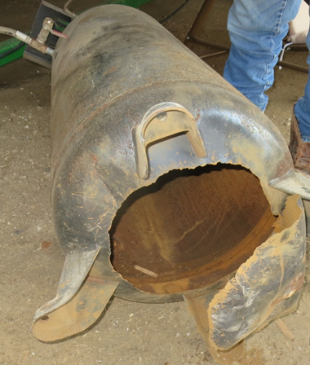
Compressed air tank with exploded bottom that was weaken by rusting.
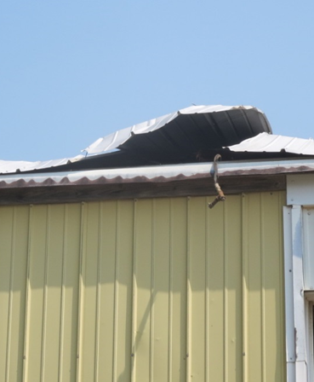
The roof that was damaged as the compressed air tank launched itself vertically.

